Data Annotation Platform
Project Execution Proposal

Version: 3.0
Date: February 2026
Prepared by: Tech Lead / Solution Architect
Status: Proposal for Client Review
Classification: Confidential

Table of Contents
1. Executive Summary
2. Our Understanding
3. Proposed Team Structure
4. Master Timeline & Phases
5. Phase 0 -- Discovery & Setup (3 Weeks)
6. Phase 1 -- MVP Foundational Platform (8 Weeks)
7. Phase 2 -- Operational Expansion (10 Weeks)
8. Phase 3 -- Optional Enhancements
9. Platform Evolution Vision
10. Technology Stack
11. Risk Management & Mitigation
12. Communication & Reporting
13. Cost & Resource Summary
14. Prerequisites from Client
15. Commitments & Guarantees
16. Key Milestone Calendar

1. Executive Summary
We will build the Data Annotation Platform from scratch with a lean, senior 4-person team. Every team member is a senior engineer who owns full vertical slices -- no hand-offs, no coordination overhead, no waiting on dependencies. Four people who each deliver end-to-end, moving fast with high ownership.
Phase | Duration | Milestone
Phase 0 -- Discovery & Setup | 3 weeks (W1-W3) | Infra live, architecture approved, portals scaffolded
Phase 1 -- MVP | 8 weeks (W4-W11) | Production-ready internal annotation platform
Phase 2 -- Enterprise | 10 weeks (W12-W21) | Consensus, benchmarks, linters, Okta SSO, customer portal
Total (Phases 0-2) | 21 weeks | Complete enterprise platform in production
Phase 3 -- Optional | TBD (W22+) | SOW-dependent enhancements

Why 4 people works:
- Zero management overhead -- the Tech Lead IS the PM, architect, and hands-on coder
- No cross-team delays -- everyone sits in one standup, one backlog, one codebase
- Senior engineers only -- we hire only seniors who move 3-5x faster than juniors
- Modern tooling -- shadcn/ui, Prisma, Turborepo eliminate weeks of boilerplate
- Longer timelines -- each person has room to go deep instead of rushing wide
The client gets the same product -- just built by a smaller, sharper team.

2. Our Understanding of the Requirement
The Data Annotation Platform is an internal, end-to-end system designed to centralize queueing, task workflows, annotation interfaces, operational tooling, quality processes, and batch-level data export. Today, annotation workflows are distributed across multiple tools and manual processes; this platform consolidates them into a unified environment.

Core Capabilities
- Configurable, multi-layer annotation and review pipelines (L1, L2, Review, Hold, Archive)
- Schema-driven task UIs supporting multiple data types (text, image, audio, video, HTML/Markdown)
- FIFO queueing with deterministic claim locking (zero double-claims)
- Rater and reviewer task interfaces for completing and validating annotations
- Operational tools for task upload, export, tagging, and pipeline management
- Benchmarks, consensus mechanisms, linters, and time-tracking
- Secure storage, access control, and full audit logging
- Workspace -> Project -> Batch -> Task -> Annotation data hierarchy
- Customer-facing portal for seat management, API keys, and usage visibility

Confirmed Scale Requirements
Metric | Confirmed Target
Daily task volume | 100,000 avg / 150,000 peak
Concurrent rater sessions | 500 avg / 800 peak
Max media file size | 500 MB per asset
Max batch upload size | No limit (streaming required)
API response time (p95) | < 300ms
UI load time (p95) | < 2 seconds
Claim collision rate | 0% (deterministic locking)

3. Proposed Team Structure
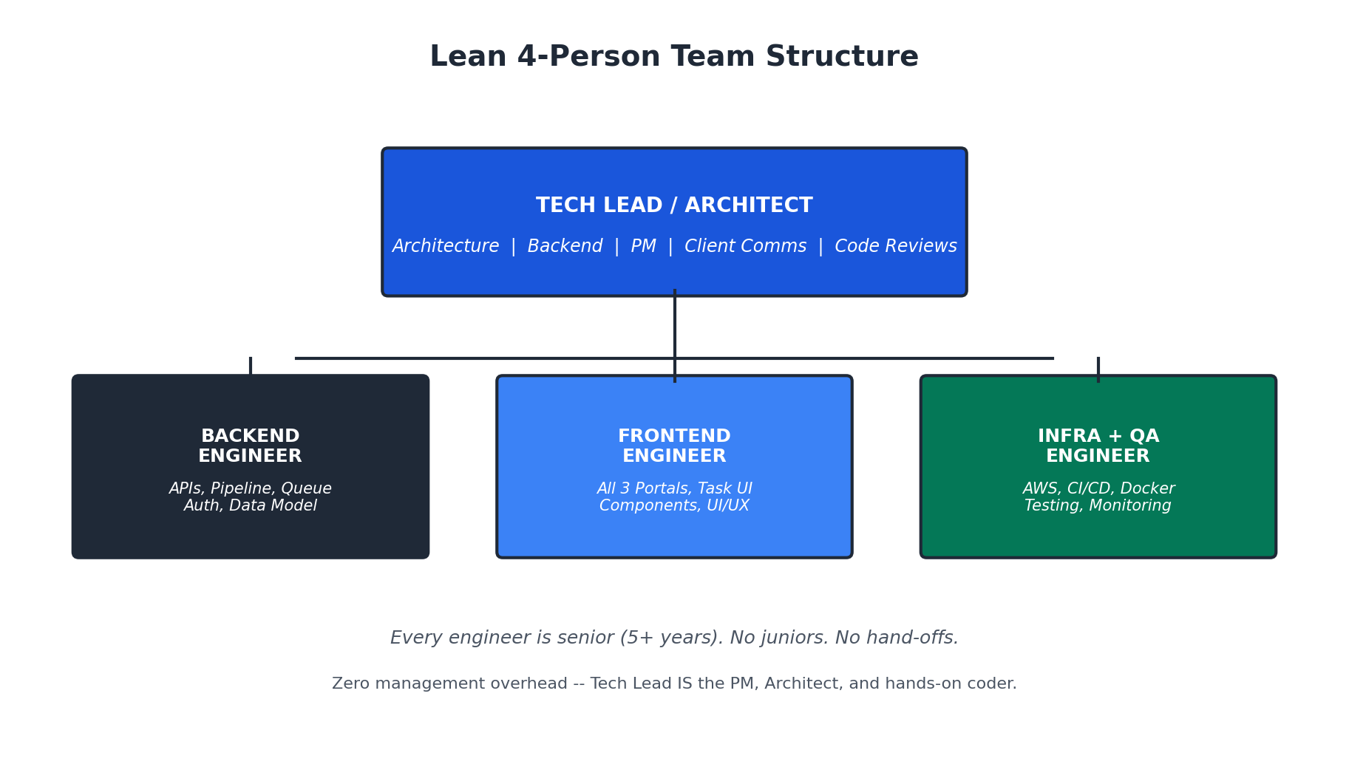
# | Role | Key Skills | What They Own
P1 | Tech Lead / Architect | Node.js, PostgreSQL, MongoDB, system design, AWS, leadership | Architecture, DB design, complex backend (claim locking, pipeline), code reviews, sprint planning, client demos. Writes 40% backend code.
P2 | Sr. Backend Engineer | Node.js/Express, PostgreSQL, MongoDB, REST APIs, concurrency | All CRUD APIs, auth system, queue engine, assignments, export, upload, linters, audit. Writes 60% backend code.
P3 | Sr. Frontend Engineer | React, TypeScript, Tailwind, shadcn/ui, media rendering, forms | All three portals (Ops, Rater, Customer), Task UI with media, schema-driven forms, component library. Owns all UI/UX.
P4 | Infra + QA Engineer | AWS, Terraform, GitHub Actions, Docker, Playwright, k6, Datadog | AWS environments, CI/CD, Docker, deployment, monitoring, E2E tests, API tests, load tests, security. S3 integration.

Why This Composition Works
Traditional (11 people) | Our Approach (4 people)
Dedicated PM | Tech Lead handles planning + client comms
Dedicated UI/UX Designer | Frontend Eng uses shadcn/ui (professional design system)
2 Backend + 2 Frontend + 1 Full-Stack | 1 Backend + 1 Frontend + Tech Lead (both)
Dedicated QA | Infra Eng handles test automation; everyone writes unit tests
Dedicated DevOps | Infra + QA combined (both about system reliability)
Coordination meetings, hand-off docs | One Slack channel, one standup, PRs are the docs

Hiring & Onboarding Plan
Week | Who Joins | What They Do Immediately
Week 1 | Tech Lead + Infra Engineer (2 people) | Infra sets up AWS; Tech Lead does architecture + DB design
Week 2 | + Backend Eng + Frontend Eng (4 people) | Backend starts APIs on Day 1; Frontend starts component library
Week 3 | Full team operational | Everyone is productive and shipping code

4. Master Timeline & Phases
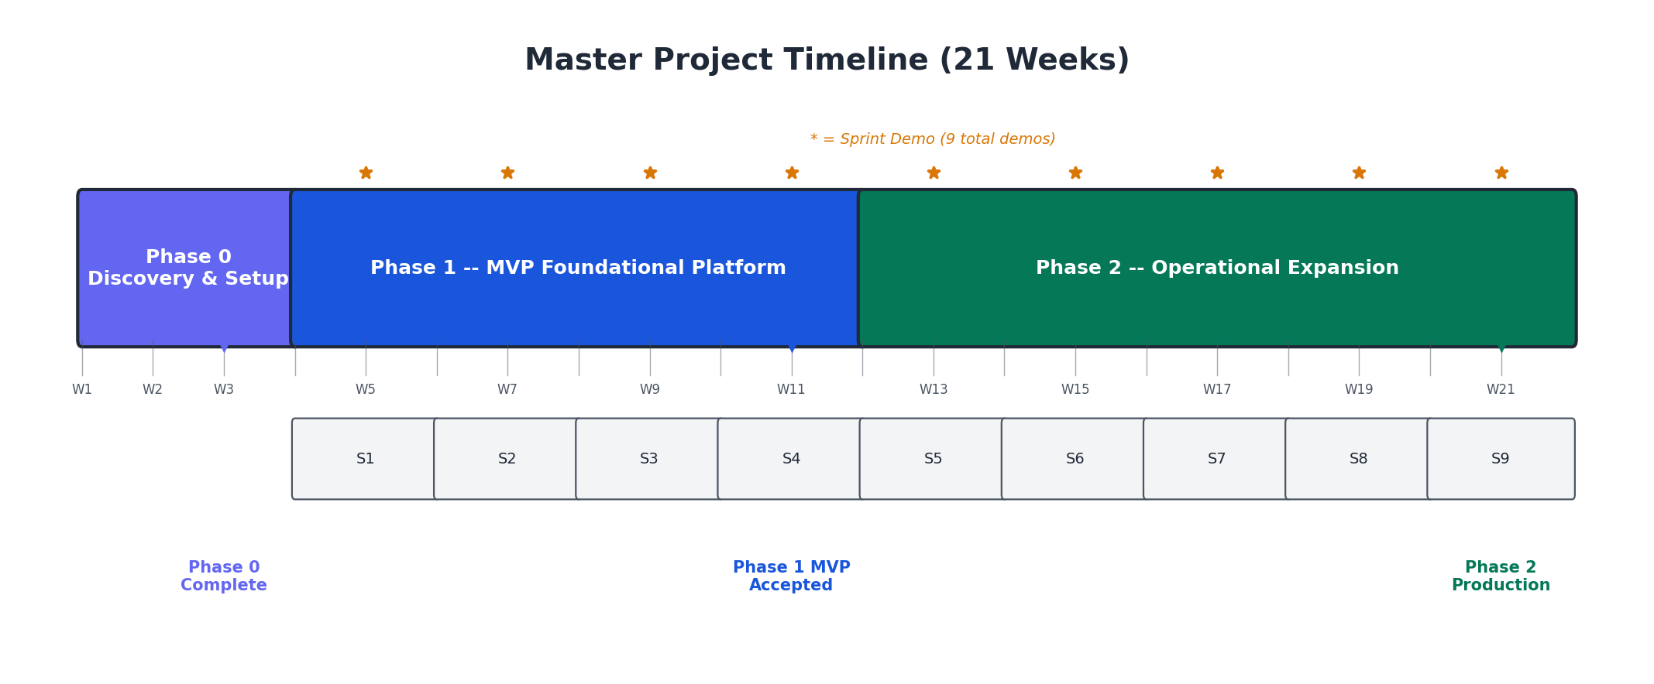

Delivery Rhythm
- Every 2 weeks: Sprint demo to client (live, in staging)
- Every week: Friday status email (3 bullets + risks)
- Every sprint: Deployable increment -- never more than 2 weeks without a working feature
- 9 total demos across Phases 1-2. Client sees progress 9 times before final delivery.
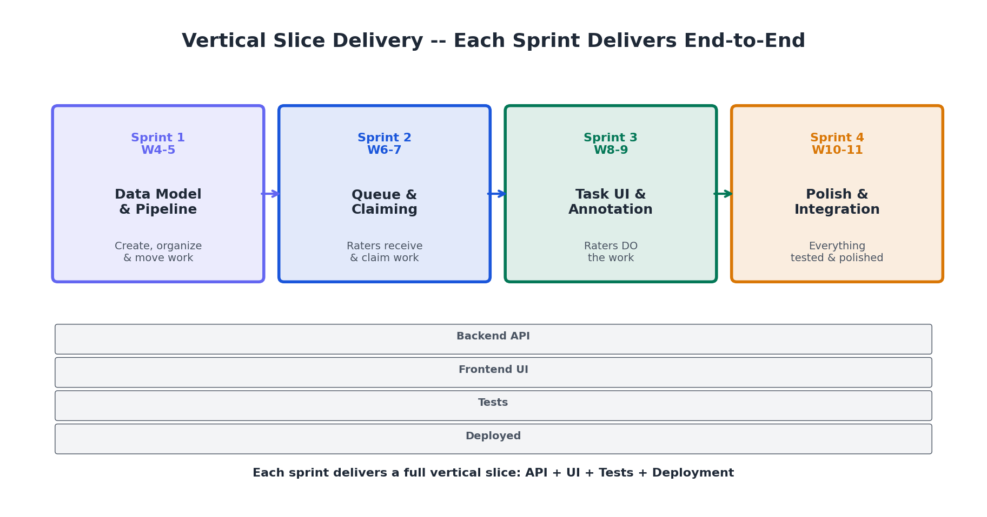

5. Phase 0 -- Discovery & Setup (3 Weeks)
Duration: 3 weeks (Weeks 1-3) | Team: 2 people (Week 1) -> 4 people (Weeks 2-3)
Goal: When Phase 1 starts on Week 4, every engineer opens their laptop and starts building features -- zero ambiguity about what to build, how to build it, or where to deploy it.

Week 1: Architecture & Infrastructure
- Client kickoff: access AWS, GitHub, Okta sandbox, Datadog; align on PRD questions
- Architecture decisions: monorepo structure, DB boundaries (PG vs Mongo), API conventions
- Database schema design: PostgreSQL ERD + MongoDB document schemas
- Provision AWS dev environment: VPC, RDS, DocumentDB, S3, ECR, ALB
- Create GitHub monorepo (Turborepo), GitHub Actions CI pipeline
- Docker Compose for local development

Week 2: Scaffolding & Design Direction
- Full team onboarding (4 people), codebase walkthrough, local env setup
- Implement PostgreSQL schema via Prisma + seed script
- Implement MongoDB schemas via Mongoose
- Build shared UI component library (shadcn/ui, 12+ base components)
- Build Ops Portal + Rater Portal shells (navigation, layout, placeholder pages)
- Implement auth module: JWT, bcrypt, login/logout/me, RBAC middleware
- Set up Playwright E2E framework + Datadog agent

Week 3: Integration & Sign-Off
- End-to-end login flow: login page -> API -> JWT -> portal -> role-based routing
- RBAC enforcement: rater cannot access Ops URLs (server-side)
- Deploy all apps to staging, S3 signed URL service working
- Sprint 1-4 backlog creation with acceptance criteria
- Client demo: staging login + portals + architecture walkthrough

What the Client Sees at End of Phase 0
A polished login page. The Ops Portal with a sidebar (Dashboard, Projects, Batches, Tasks, Users) -- pages are placeholder but navigation and design language are real. A separate Rater Portal. RBAC works: raters get 403 on Ops URLs. In GitHub: a clean monorepo with green CI and automated deploys. It looks like a real product. It just does not do anything yet. But the skeleton is rock-solid.

6. Phase 1 -- MVP Foundational Platform (8 Weeks)
Duration: 8 weeks (W4-W11) | 4 two-week sprints | Team: 4 people
Goal: A production-ready internal annotation platform that replaces manual task distribution.

Sprint 1 (Weeks 4-5): Data Model & Pipeline Engine
Theme: "Work can be created, organized, and moved through a pipeline"
- Pipeline engine: configurable stages in MongoDB, state machine for transitions
- Response schema system: JSON Schema storage, ajv validation, per-level schemas
- Full CRUD APIs: Workspace, Project, Batch, Task, Annotation
- Ops Portal: project pages, pipeline config UI, batch & task views
- S3 file upload integration with presigned URLs

Sprint 2 (Weeks 6-7): Queue, Assignment & Claiming
Theme: "Raters receive work and can claim it without conflicts"
- Claim locking engine: SELECT FOR UPDATE SKIP LOCKED -- zero double claims
- FIFO queue engine with Redis sorted set cache for 100K tasks/day
- Assignment system: manual and automatic, batch-level
- Rater Portal: task queue, "Start Next Task" button, claim flow with heartbeat
- Media renderers: image zoom/pan, audio waveform, video player, HTML/Markdown
- Concurrency load test: 50 raters claiming simultaneously -- zero collisions

Sprint 3 (Weeks 8-9): Task UI & Annotation Flow
Theme: "Raters open tasks, see rich media, fill out annotation forms, and submit"
HIGHEST RISK SPRINT: Client confirmed Task UI requires conditional logic, nested schemas, and repeater sections. Tech Lead pair-programs with Frontend Engineer during this sprint.
- Recursive schema-driven form renderer: conditional fields, nested objects, array repeaters
- Annotation submission pipeline: validate, store in MongoDB, update PG, advance pipeline
- Reviewer flow: see all prior annotations + reviewer-only fields
- Full rater flow: claim -> media + dynamic form -> submit -> auto-load next

Sprint 4 (Weeks 10-11): Polish, User Management & Phase 1 Acceptance
Theme: "Everything works end-to-end, is tested, documented, and ready for sign-off"
- User management: create, edit, list, deactivate, roles, bulk CSV import
- Basic export API (JSON/CSV), activity logging to Datadog
- Full UI polish: error states, loading skeletons, toast notifications, responsive design
- Full regression E2E suite (40+ tests), load test (100 concurrent raters)
- OpenAPI/Swagger docs, architecture diagrams, developer setup guide

Phase 1 Deliverables
- Data Model: Workspace -> Project -> Batch -> Task -> Annotation hierarchy, full CRUD APIs
- Pipeline Engine: Configurable multi-stage pipeline, status transitions, Ops controls
- Queue System: FIFO ordering, deterministic claim locking, assignment, heartbeat + timeout
- Task UI: Media rendering (text/image/audio/video/HTML), schema-driven response forms with conditional logic + repeaters
- Rater Portal: Task queue, claim, annotate, submit, auto-next
- Ops Portal: Project setup, pipeline config, batch creation, task upload, assignments, filtering
- Auth: JWT login, RBAC enforcement (server-side), internal vs external separation
- Storage: S3 structured storage with signed URLs for upload and retrieval
- Tests: 40+ E2E tests, API tests, concurrency load tests -- all green in CI
- Documentation: OpenAPI/Swagger API docs, architecture summary, setup guide

7. Phase 2 -- Operational Expansion (10 Weeks)
Duration: 10 weeks (W12-W21) | 5 two-week sprints | Team: 4 people
Goal: Enterprise-grade operations -- 10+ concurrent projects, quality controls, Okta SSO, customer portal.

Sprint 5 (W12-13): Consensus & Benchmarks
- Consensus engine: N annotations per task, same task served to N raters, aggregation view
- Benchmark system: golden tasks, gate mode (blocks until X%), interleaved injection
- Rater levels and mass assignment by level
- Reviewer consensus view: side-by-side display of all N annotations

Sprint 6 (W14-15): Bulk Upload, Export & Ops Controls
- Streaming bulk upload: NDJSON/CSV, real-time progress, error reporting
- Batch export: CSV/JSON + media URLs + ZIP packaging
- Reset/archive/ignore controls (single + bulk) with full audit trail
- Load test: 10K task upload < 2 min, 5K export < 60s

Sprint 7 (W16-17): Linters, Time Tracking & Tags
- Pluggable linter framework: blocking vs warning mode, 3 built-in linters
- Time tracking: active time per task, idle detection, Ops queryable
- Tag management: bulk tags on tasks + raters, tag-based filtering

Sprint 8 (W18-19): Customer Portal, Okta SSO & Audit
- Okta SSO: OAuth2 PKCE, JIT provisioning, session management
- Customer Portal: org dashboard, seat management, API key, annotation volume
- Full audit logging: searchable, filterable, 15-day retention with cleanup

Sprint 9 (W20-21): GUI UI Builder, Impersonation & Final Polish
- GUI UI Builder: visual schema editor with live preview, versioned
- Admin impersonation: time-bounded, logged, with clear UI indicator
- Full regression suite (80+ E2E tests), load test (200 concurrent raters)
- Production deployment: all services, monitoring, alerting

Phase 2 Deliverables
- Consensus workflows (N annotations per task, side-by-side reviewer view)
- Benchmark system (golden tasks, gate + interleaved modes)
- Bulk upload (streaming NDJSON/CSV, progress, error reports) + batch export (CSV/JSON/ZIP)
- Linter framework (pluggable, blocking/warning, 3 built-in) + time tracking
- Tag management, rater levels, project-level assignment
- Okta SSO (OAuth2 PKCE) replacing JWT auth
- Customer Portal (subscription, seats, API key, usage metrics)
- Full audit logging (searchable, 15-day retention)
- GUI UI Schema Builder (visual editor, live preview)
- Admin impersonation (time-bounded, audited)
- Production environment deployed, monitored, and alerted
- 80+ E2E tests, 200-user load tests, security checklist complete

8. Phase 3 -- Optional Enhancements
Duration: TBD (SOW-dependent) | Team: 4 people (or scale to 5-6)
Feature | Estimated Effort | PRD Refs
Drafts / autosave | 2 weeks | UI-06
Advanced assignment (random/LIFO/weighted) | 1.5 weeks | QUEUE-05
Pre/post-processing pipelines (Lambda) | 3 weeks | PROC-01
Prelabels/predictions in UI | 2 weeks | PROC-02
Custom grader logic (secure sandbox) | 3 weeks | MISC-05
Ops dashboard (status counts + drill-down) | 2 weeks | OPS-05
Advanced task filtering | 1.5 weeks | OPS-07
Notification center | 1.5 weeks | MISC-04
Customer upload/download UI | 2 weeks | CUST-03
Customer analytics dashboard | 2 weeks | CUST-02

Total if all selected: ~22 weeks. We recommend selecting 8-10 weeks of features per SOW.

9. Platform Evolution Vision
The platform grows incrementally across phases. Here is what the client will see at each milestone:
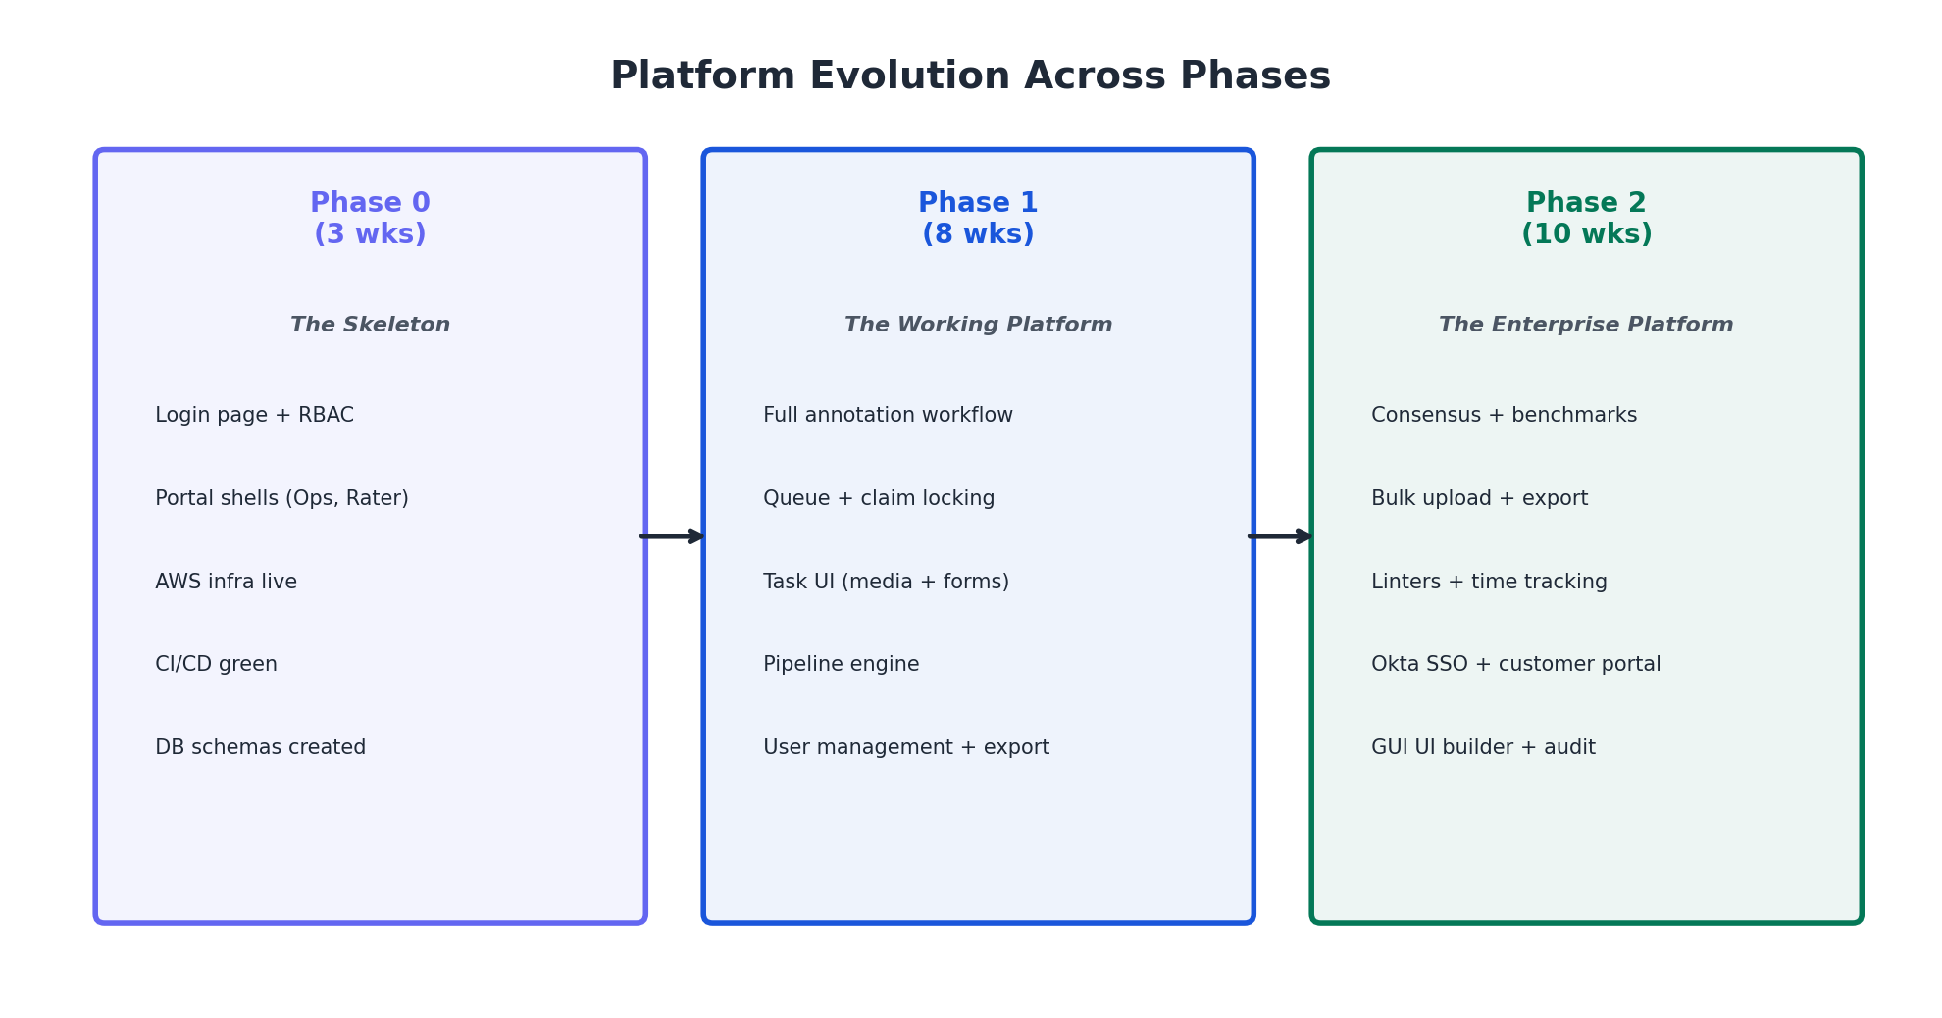
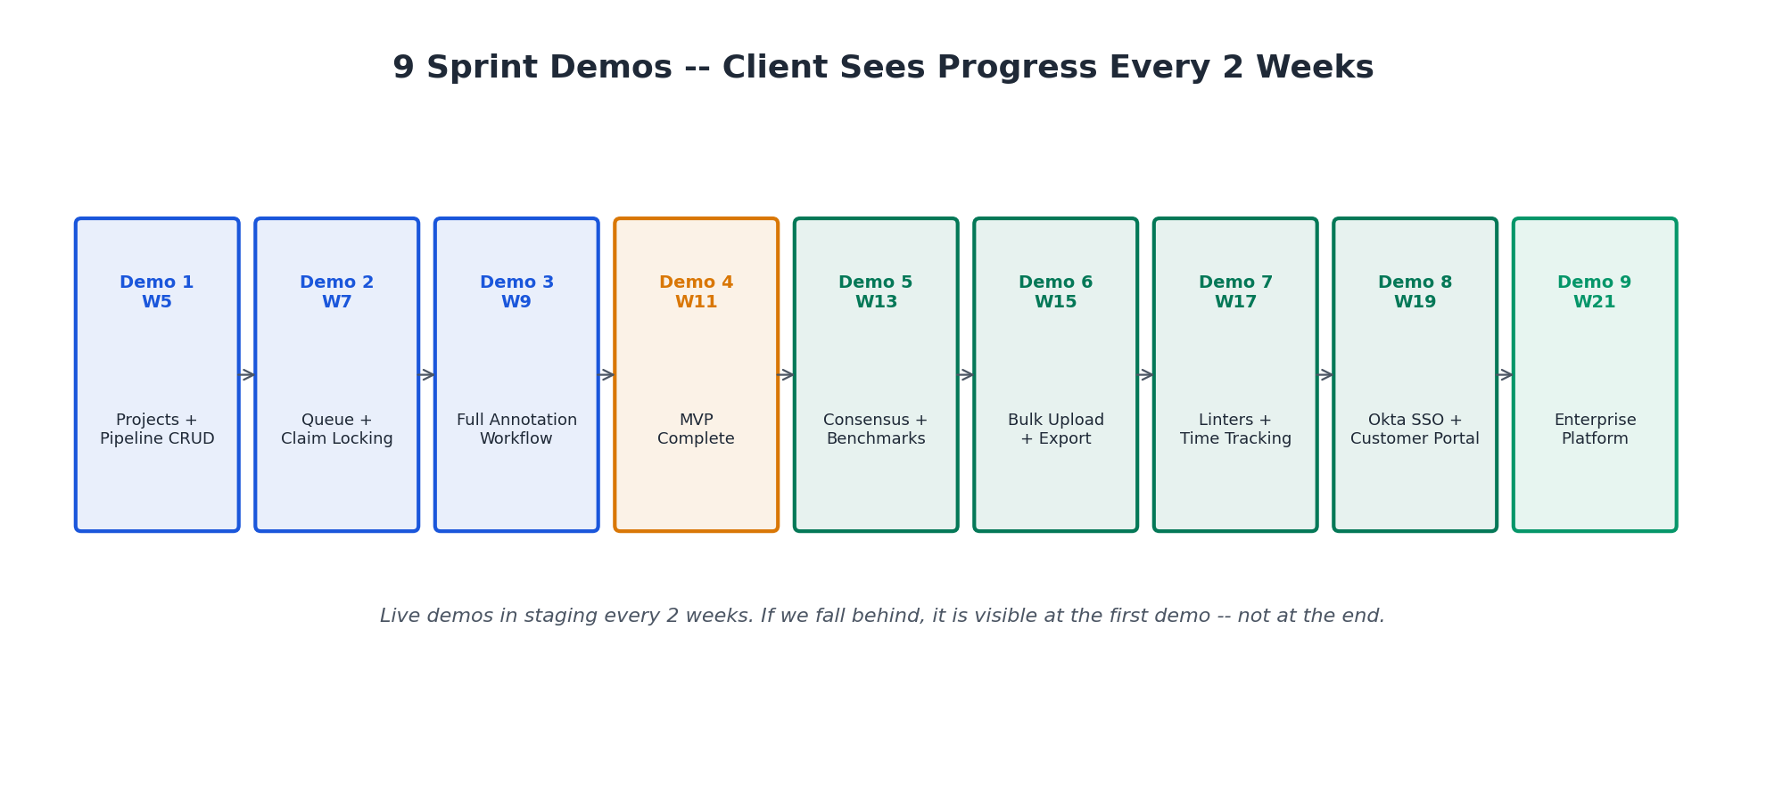

10. Technology Stack
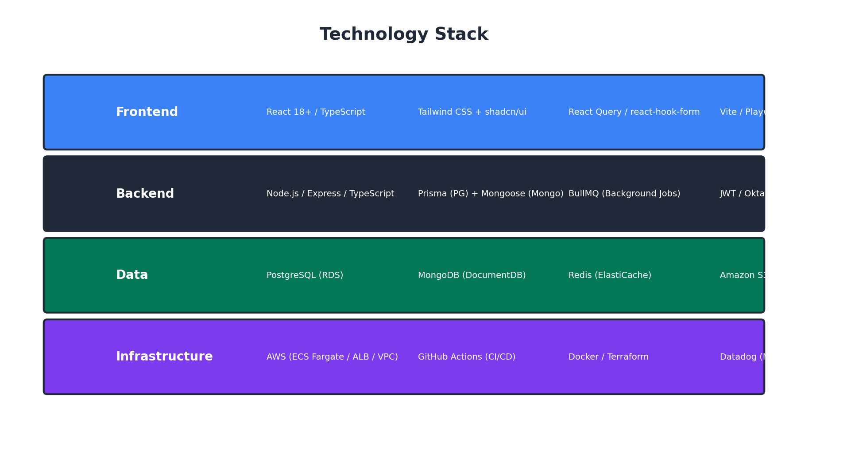
Layer | Choice | Why
Monorepo | Turborepo | Fast incremental builds, shared types, single CI pipeline
Backend | Node.js + Express + TypeScript | Client-mandated
Frontend | React + TypeScript + Tailwind CSS | Client-mandated
UI Components | shadcn/ui (Radix + Tailwind) | Professional design system without a designer
PostgreSQL ORM | Prisma | Type-safe queries, auto-migrations, great DX
MongoDB ODM | Mongoose | Schema validation, middleware hooks, mature
Cache Layer | Redis (ElastiCache) | Queue caching, sessions, task counts at 100K/day
Auth (Phase 1) | JWT (bcrypt + jsonwebtoken) | Simple, swappable via adapter pattern
Auth (Phase 2) | Okta OAuth2 PKCE | Client-mandated SSO
Object Storage | AWS S3 + presigned URLs | Client-mandated
CI/CD | GitHub Actions | Client-mandated
Containers | Docker + ECS Fargate | Serverless containers, no cluster management
Monitoring | Datadog | Client-mandated
Testing | Playwright + Jest + k6 | E2E, unit/API, load testing

11. Risk Management & Mitigation
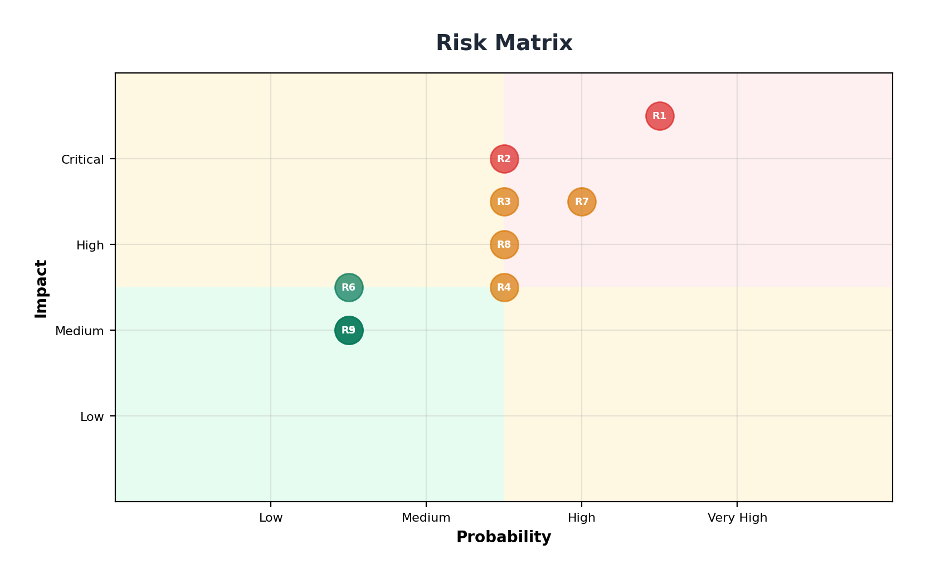
# | Risk | Probability | Impact | Mitigation
R1 | Bus factor = 1 per domain | High | Critical | Tech Lead is capable backup for both. All code PR-reviewed. Critical modules pair-programmed.
R2 | Someone leaves or gets sick | Medium | Critical | All code documented + PR history. Tech Lead covers temporarily. Replace within 1-2 weeks.
R3 | Phase 1 scope tight for 8 weeks | Medium | High | Sprint 4 is buffer sprint. Scope frozen at Phase 0 sign-off.
R4 | No dedicated QA -- bugs slip | Medium | Medium | Infra Eng owns automation (E2E + load). All devs write unit tests. PRs blocked without tests.
R5 | No designer -- UI quality risk | Low | Medium | shadcn/ui provides professional design out of the box. Frontend Eng has UI/UX sense.
R6 | No PM -- communication gaps | Low | Medium | Tech Lead handles client comms directly. 2x/week sync. Friday status emails.
R7 | Claim locking concurrency bugs | Medium | High | PostgreSQL SKIP LOCKED is proven. 1000-run concurrency test in Sprint 2.
R8 | Client feedback delays | Medium | High | Sprint demos every 2 weeks. Async Slack with 4-hour SLA.
R9 | Okta integration complications | Low | Medium | Auth adapter pattern isolates Okta from Phase 1 code. Dedicated sprint for auth swap.

Bus Factor Mitigation
Domain | Primary | Backup | Emergency
Backend | Backend Eng | Tech Lead | Hire in 1-2 weeks
Frontend | Frontend Eng | Tech Lead | Hire in 1-2 weeks
Infra | Infra Eng | Backend Eng (CI/CD basics) | Tech Lead (AWS basics)

12. Communication & Reporting
Meeting | Frequency | Duration | Attendees | Purpose
Daily Standup | Daily | 10 min | All 4 engineers | Blockers, priorities
Client Sync | 2x/week (Tue + Thu) | 30 min | Tech Lead + Client PO | Progress, decisions
Sprint Demo | Every 2 weeks | 45 min | All 4 + Client stakeholders | Live demo in staging
Knowledge Share | Weekly (Fri) | 30 min | All 4 engineers | Each person demos work
Sprint Planning | Every 2 weeks (Mon) | 60 min | All 4 engineers | Next sprint backlog

With 4 people, total meeting time is ~3.5 hours/week. An 11-person team would spend 8-10 hours/week in meetings.
Artifact | Frequency | Content
Sprint Demo | Every 2 weeks | Live walkthrough of new features in staging
Friday Email | Weekly | 3-bullet summary, risks, next week plan
Phase Report | Per phase | Deliverable checklist, test results, performance metrics

Purpose | Tool
Project tracking | Linear (lightweight, fast for small teams)
Communication | Slack: #annotation-platform (client) + #annotation-team (internal)
Code | GitHub (client org)
CI/CD | GitHub Actions
Monitoring | Datadog

13. Cost & Resource Summary

Team Cost
Role | Count | Monthly Cost (INR)
Tech Lead / Architect | 1 | INR 1,40,000 - 1,50,000
Senior Backend Engineer | 1 | INR 1,40,000 - 1,50,000
Senior Frontend Engineer | 1 | INR 1,40,000 - 1,50,000
Infra + QA Engineer | 1 | INR 1,40,000 - 1,50,000
Total Team (4 people) | 4 | INR 5.6L - 6.0L /month

Phase Cost Projection
Phase | Duration | Estimated Cost (INR)
Phase 0 (ramp: avg 3 people) | 3 weeks | INR 3.86L – 4.13L
Phase 1 (full team) | 8 weeks | INR 10.3L - 11.1L
Phase 2 (full team) | 10 weeks | INR 12.9L - 13.9L
Total Phases 0-2 | 21 weeks | INR 26.1L - 28.1L
Phase 3 (scope-dependent) | TBD | Rate x duration

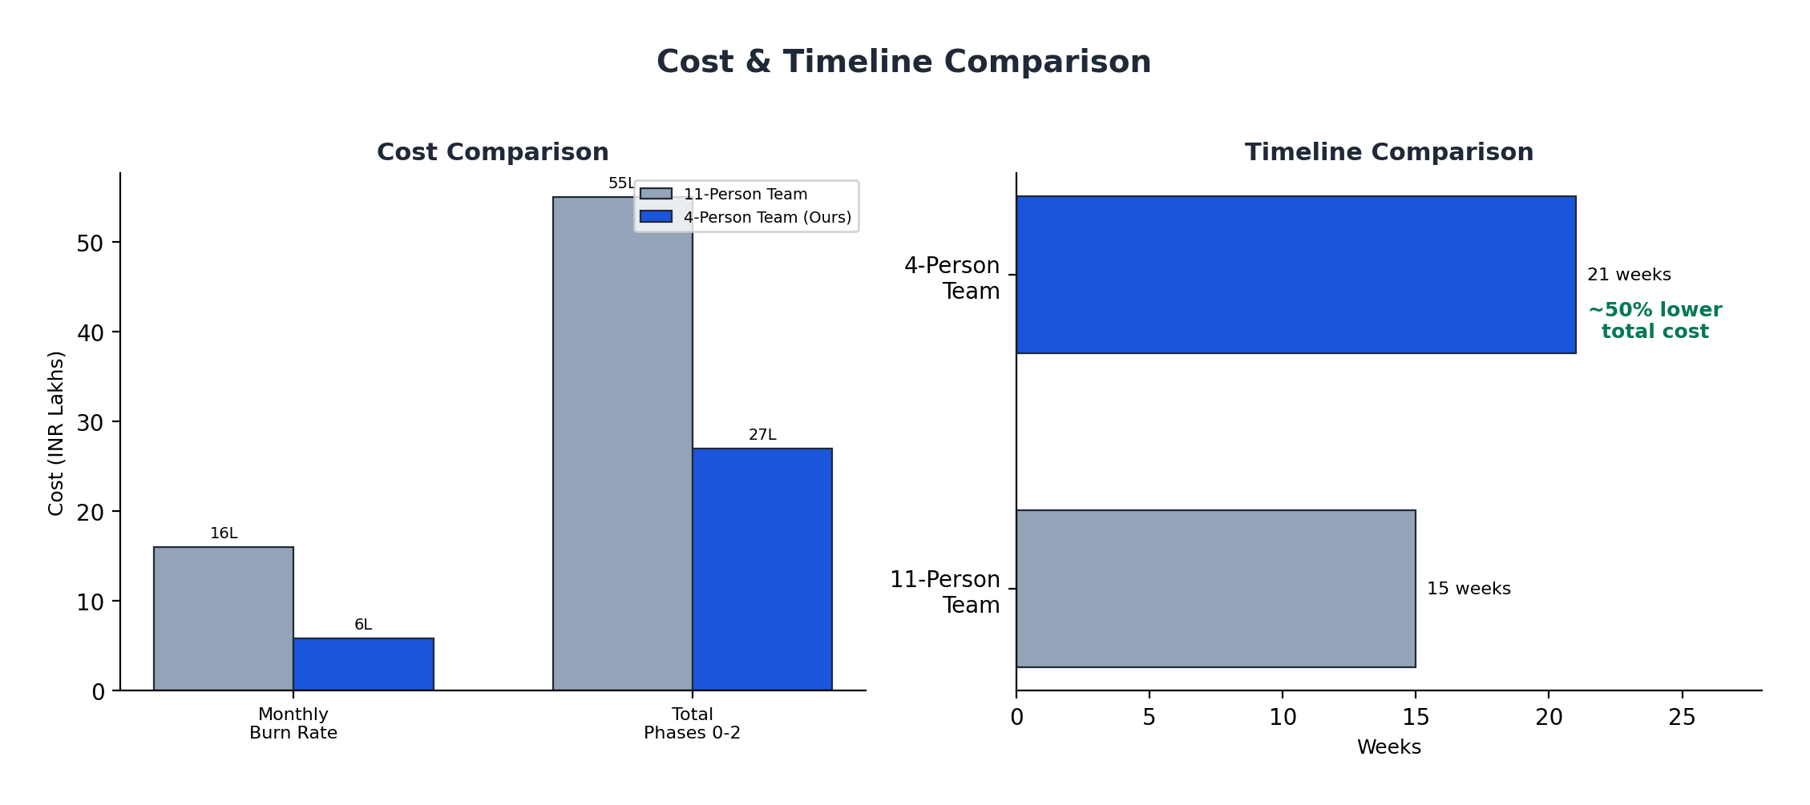
The 4-person team costs ~50% less in total while taking 40% more calendar time. The tradeoff is time for money -- the client gets the same product at significantly lower total cost.

AWS Infrastructure (100K Tasks/Day Scale)
Note: AWS infrastructure is billed in USD globally. Costs shown in USD and INR equivalent (at ~INR 84/USD).
Service | Sizing | Monthly Cost (USD) | Monthly Cost (INR)
RDS PostgreSQL | db.r6g.xlarge + read replica | $800 - $1,200 | INR 67K - 1.0L
DocumentDB (MongoDB) | db.r6g.xlarge | $500 - $750 | INR 42K - 63K
ElastiCache Redis | cache.r6g.large | $200 - $350 | INR 17K - 29K
ECS Fargate (4 services) | Auto-scaling API | $400 - $700 | INR 34K - 59K
S3 (10 TB) | 500MB files x high volume | $250 - $500 | INR 21K - 42K
ALB + Route53 |  | $50 - $100 | INR 4K - 8K
ECR |  | $10 - $20 | INR 1K - 2K
Total AWS (Staging + Prod) |  | $2,210 - $3,620/mo | INR 1.86L - 3.04L/mo

14. Prerequisites from Client
Everything below must be completed or confirmed BEFORE Week 1, Day 1. We recommend starting 2-3 weeks before the planned kickoff date.

Contractual & Legal
- SOW / Contract signed
- Mutual NDA for all 4 team members
- IP assignment agreement (work-for-hire confirmed)
- Change control process

AWS & Infrastructure
- AWS account access (Tech Lead + Infra Eng)
- AWS region confirmed
- AWS budget approved ($2K-$4K/month)
- Domain names decided

GitHub
- GitHub org access for all 4 members
- Repo creation permission
- GitHub Actions minutes confirmed
- PR review process agreed

Okta (for Phase 2)
- Okta sandbox access requested (can arrive by Week 2)

Monitoring
- Datadog org access
- API key + Application key provided

Client Stakeholders
- Product Owner named and available
- Technical Point of Contact
- Executive Sponsor
- Communication channel created
- Recurring meeting invites sent

Technical Decisions
- Tech stack confirmed
- Container orchestration (ECS vs EKS)
- IaC tool (Terraform vs CDK)
- Environments confirmed (dev/staging/prod)

Scale & Performance
- All scale assumptions reviewed and confirmed (100K tasks/day, 800 peak users)

Domain Knowledge
- Current workflow walkthrough scheduled
- Sample task data delivery by Week 2

15. Commitments & Guarantees
Senior-only team: Every person has 5+ years of experience. No juniors learning on your project. Four people who each operate independently at a high level.
Working software every 2 weeks: 9 sprint demos across Phases 1-2. The client sees real features running in staging every 14 days. If we fall behind, it is visible at the first demo -- not at the end.
Full transparency: Code in the client's GitHub. Staging accessible 24/7. Datadog dashboards shared. Linear board visible. No black boxes.
Deep ownership: Each engineer owns their domain end-to-end. The person who builds the API also writes the tests and monitors the logs. Fewer bugs, faster debugging, stronger accountability.
Scope discipline: Phase 1 P0 requirements frozen at Phase 0 sign-off. Sprint 4 is our built-in buffer. We plan conservatively and execute precisely.
Knowledge transfer: All architecture decisions in ADRs. APIs documented in OpenAPI/Swagger. Components with usage examples. Runbooks for operations. The codebase stands on its own.
Post-delivery warranty: 4-week warranty after each phase. P0 bugs (system down): 24hr response, 48hr fix. P1 bugs (feature broken): 48hr response, 1-week fix. P2 bugs (cosmetic): logged, no SLA.

Success Metrics
Phase | Success =
Phase 0 | Staging live. Architecture approved. Backlog estimated. Team shipping code.
Phase 1 | End-to-end annotation workflow in staging. All P0 requirements pass acceptance. 100 concurrent raters with zero double-claims.
Phase 2 | 10+ concurrent projects with isolation. Okta SSO working. Bulk upload/export at scale. Customer portal live. Full audit trail. Production deployed.

16. Key Milestone Calendar
Week | Milestone | What Client Sees
W1 | Kickoff + infra provisioning | Architecture doc + AWS environments
W2 | Full team onboard | Working local dev stack
W3 | Phase 0 Complete | Login + portal shells in staging
W5 | Sprint 1 Demo | Projects + pipelines + task CRUD working
W7 | Sprint 2 Demo | Queue + claiming + assignment working
W9 | Sprint 3 Demo | Full annotation flow (claim -> annotate -> review -> done)
W11 | Phase 1 MVP Accepted | End-to-end platform in staging
W13 | Sprint 5 Demo | Consensus + benchmarks + rater levels
W15 | Sprint 6 Demo | Bulk upload + export + reset/archive
W17 | Sprint 7 Demo | Linters + time tracking + tags
W19 | Sprint 8 Demo | Customer portal + Okta SSO + audit logs
W21 | Phase 2 Accepted | Enterprise platform in production
W22+ | Phase 3 Kickoff | Per SOW

Why Choose This Approach
 | Large Team (11 people) | Our Lean Team (4 people)
Decision speed | Committee discussions, review boards | Tech Lead decides in real-time, team executes
Communication | 11 people x n channels = noise | 4 people in one room = clarity
Code consistency | Multiple authors, different styles | Tech Lead reviews every PR, consistent patterns
Accountability | "That's the other team's module" | "I built it, I own it, I'll fix it"
Client relationship | PM relays messages through layers | Tech Lead talks to client directly
Total Cost | INR 53L - 57L | INR 26L - 28L

We have chosen the hardest path -- a small team with no room for passengers. Every person must perform. But the result is a tighter codebase, clearer ownership, and a lower bill.

This proposal is the technical foundation for the Statement of Work. All timelines, costs, and commitments are subject to final SOW agreement.

